An Introduction to Graph Theory
Discrete Mathematics

Introduction
This paper serves as an introduction to the field of graph theory. A lot of the material presented here will be covered in class, however it is up to the individual student to read and become familiar with the contents of this handout over the course of the semester. If you are unsure of anything, please come and ask about it during tutorials.
Informally, a graph is a collection of vertices connected by edges. Graphs are used to model a wide variety of situations. This is achieved by using points to symbolise specific entities and then connecting those points with lines which denote certain relationships. We will start by considering a few simple examples of situations that can be modelled using a graph:
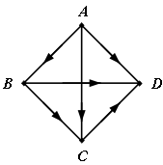
- The results of tournaments in which the points represent individual players, see Figure1.

Figure 1
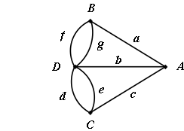
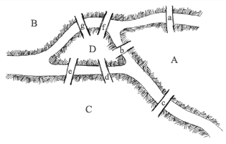
- Locations on a map, as in the classic problem of the bridges of Königsberg solved by Euler in 1736. How can one walk once and only once across each of the bridges of Königsberg and finish back at the starting point? The problem is illustrated in Figure 2.
Figure 2
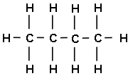
- Representation of chemical compounds such as Butane. See Figure 3.
Figure 3
This abstraction of reality through graphs has two advantages:
- We are able represent the deep structure of the problem.
- From a practical point of view, it presents an overall view of the problem which is a valuable guide for intuition and reasoning.

Definitions
Before formulating or solving any problems using graphs, we need to learn the language of graph theory. The basic vocabulary of this language will be presented in this section as a series of definitions. Most of the terms used are self explanatory and have the usual meaning accorded to them in English. An intuitive knowledge of sets and memberships of a set is assumed.
Note: The vocabulary used in graph theory is by no means standardised across the field. Although this course will be consistent in its terminology, it is advisable to check that a term means what you think it does when reading books on graph theory.
Definition 1
A graph is a set of points called vertices or nodes, which are connected by a set of lines called edges or arcs. Thus for a graph G we denote the vertex set by V and the edge set by E and write G = (V, E).
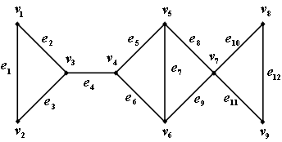
Figure 4
Figure 4 shows the graph 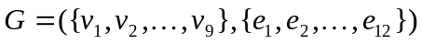, so 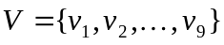 and 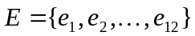.
We may also specify an edge in terms of the two vertices that it connects. These vertices are called end points. Thus in Figure 4 we may write 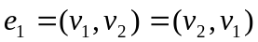. Note that at this stage the order of the vertices in this representation is not important. Using this alternative notation, we may write E in the form
The number of elements in a set S is denoted by 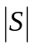. Thus for a graph G the number of edges is given by 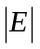and the number of vertices by 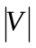. Later we shall use the number of vertices as an indication of the complexity of a graph, so we let 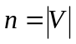. Normally, n and are finite numbers, in which case G is said to be a finite graph. If 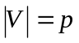 and 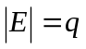then we say that G is a (p, q)-graph, where p is the order of G and q is the size of G.
Definition 2
An edge e is incident with a vertex v if v is an end point of e.
In Figure 4, the edges 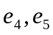 and 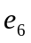are incident with the vertex 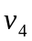.
Definition 3
If for any two vertices, u and v we have 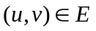, then u is said to be adjacent to v. That is, u and v are end points of the same edge. We say that two edges are adjacent if they have a common end point.
The vertex in Figure 4 is adjacent to 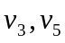 and 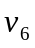.
Definition 4
The degree of a vertex v, written 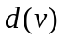, is the number of edges incident with v. An isolated vertex has 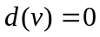.
Looking again at Figure 4, we see 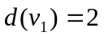and 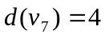. Now consider Figure 5.

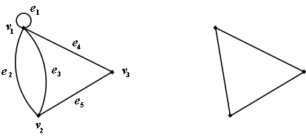
Figure 5
(a)
(b)
Definition 5
A self loop is an edge 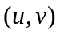 for which .
Thus 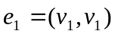 in Figure 5(a) is a self loop. A self loop might occur if for example Figure 5(a) represents a system of roads and 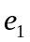 is a car park at 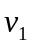.
Definition 6
A parallel edge joining u to v is an edge for which is not unique.
In Figure 5(a) 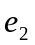 and 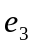 are parallel edges that both join to 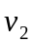. Thus if Figure 5(a) represents a road system, could be a new road constructed to ease the flow on an existing saturated road .
Definition 7
A simple graph is one that contains no self loops or parallel edges. A multiple graph is one with parallel edges but no self loops.
The underlying simple graph of Figure 5(a) is given by Figure 5(b). The underlying simple graph of any graph is obtained by ignoring the loops and multiple edges in the graph.
Unless otherwise stated, we will confine ourselves to the consideration of simple graphs throughout this course.

Examples of Graphs
This section defines and illustrates some common types of graphs.
Definition 8
A graph whose edge set is empty is called a null (or totally disconnected) graph. We denote the null graph with n vertices by 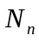.
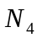 is shown in Figure 6(a).
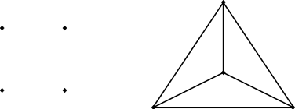
(a)
(b)

Figure 6
Definition 9
A graph in which every pair of distinct vertices is adjacent is called a complete graph. A complete graph on n vertices is denoted by 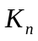.
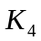 is shown in Figure 6(b).
Definition 10
A graph in which every vertex has the same degree is called a regular graph. If every vertex has degree k, then the graph is said to be k-regular.
Therefore, every null graph is 0-regular and the complete graph , is 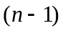-regular. Figure 7 shows two examples of 3-regular graphs (also called cubic graphs).
(a)
(b)
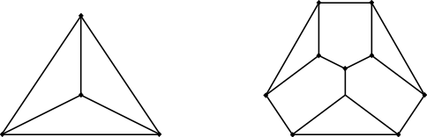

Figure 7
Definition 11
Suppose that the vertex-set of a graph G can be split into two disjoint sets 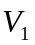 and 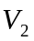 in such a way that every edge of G joins a vertex in to a vertex in , and vice versa. Then G is said to be a bipartite graph.
Figure 8 shows two bipartite graphs.
(a)
(b)
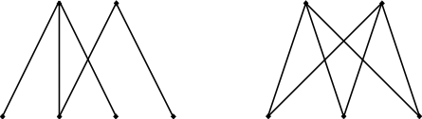

Figure 8
Note that in a bipartite graph it is not necessary for every vertex of to be adjacent to every vertex of . However, if this does happen, then G is called a complete bipartite graph. In this case we denote the graph by 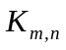where 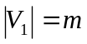 and 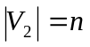. Figure 8(b) shows 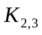.
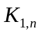is called a star-graph for obvious reasons. (Draw one).
Definition 12
Two graphs 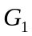 and 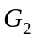 are said to be isomorphic if there is a one-to-one correspondence between the vertices of and such that adjacency and nonadjacency is preserved.
That is, 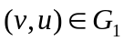 if and only if 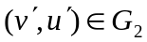, where v and 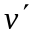, u and 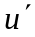correspond. Figure 9 presents two representations of 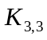 and hence the graphs are isomorphic.
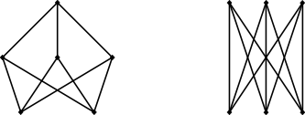
(a)
(b)

Figure 9

New Graphs From Old
There are a number of ways in which new graphs may be produced from one or more given graphs.

The Union of Two Graphs
The union of two graphs is a method for combining two or more graphs to form one new graph, and is an example of a graph operation.
Definition 13
Let 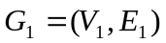 and 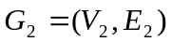 be two graphs where and are disjoint sets. Then the union of and , denoted by 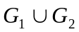 or 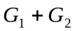, is defined to be the graph with vertex set 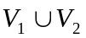 and edge set 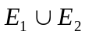.
Figure 10 gives an example.
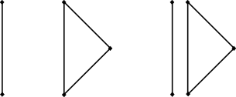

Figure 10

Deletions and Contractions
Given a graph , it is possible to create a new graph, , by removing edges and/or vertices from .
Definition 14
Let and be two graphs. Then is said to be a subgraph of , denoted 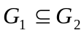, provided that 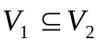 and 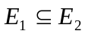. Furthermore, is said to be a proper subgraph of , denoted 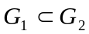, provided that 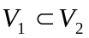 and 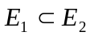.
Therefore, a subgraph H of G is a graph is obtained through the removal of a number of edges and/or vertices of G. H is proper subgraph of G if at least one edge or vertex of G has been removed.
The removal of a vertex from graph G implies the removal of every edge incident with it. The removal of an edge, however, does not remove its end points, even though this may result in an isolated vertex. If we remove an edge e or a vertex v from G, the resultant graphs, called deletions, are denoted respectively by 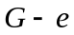 or 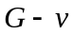.
Definition 15
For a graph 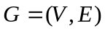 if we let 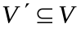, then the subgraph of G induced by 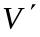is the subgraph with vertex set and edge set consisting of those edges of G incident with vertices of . We denote this induced subgraph by 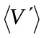.

Paths and Circuits
In order to traverse a graph, we move from one vertex to another along a series of adjacent edges. In this section we will look more closely at the different characteristics of graph traversals.
Definition 16
In a graph G, a walk from a vertex to a vertex 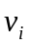, called a 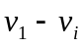 walk, is a finite alternating sequence of vertices and edges 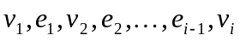.
In general, we will use a more compact notation for walks, listing only the vertices involved. The existence of an edge between the pairs of adjacent vertices is implied. So the above walk becomes the vertex sequence 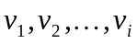.
Definition 17
A trail is a walk in which no edge is repeated.

Definition 18
A path is a walk in which no vertex or edge is repeated.
A path, walk or trail is said to be closed if 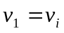 and open if 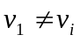.
Definition 19
A circuit or cycle of a graph G is a closed path. The length of a path or circuit is the number of edges it contains. Two paths or circuits are said to be edge disjoint if they have no edge in common.

Definition 20
In a graph G two vertices, and , are said to be connected if there is a path from to . By convention every vertex is connected to itself. In general we say G is connected if every pair of its vertices are connected, otherwise is it disconnected.
The graphs in Figures 7, 8 and 9 are connected whereas the union in Figure 10 is disconnected.
In general, a disconnected graph G will consist of vertex subsets 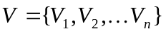, such that for each 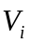 all 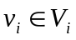 are connected, and any pair of vertices from different vertex subsets are disconnected. The subgraphs induced by the are called components of the graph, they are the maximum-sized connected subgraphs of G.
See the union in Figure 10 for an example where the vertex-set is 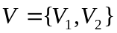. The graph has two components.
Definition 21
Let G be a connected graph, then the vertex v is said to be an articulation point or cut vertex if the removal of v disconnects G. If G has no cut vertex then it is called a block.
In Figure 4, 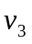, and 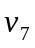 are all cut vertices.
Definition 22
Let G be a connected graph, then the edge e is said to be a cut edge if its removal disconnects G. The end points of a cut edge are cut vertices.
The edge 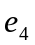 in Figure 4 is a cut edge. Note that its end points, and , are both cut vertices.
Figure 12 below shows what happens to Figure 4 when cut edge and cut vertex are removed. The resultant graph is a disconnected graph with three components.
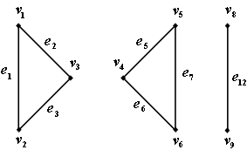

Figure 12

Directed Graphs / Digraphs
A graph in which each edge has a direction associated with it is called a directed graph or digraph. Figure 13 gives us two examples of digraphs.
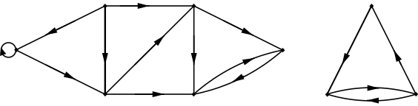

Figure 13
Note that each directed graph has an underlying simple graph, obtained by ignoring the direction of the edges (as well as any parallel edges and self loops). Figure 14 illustrates the underlying simple graphs of the digraphs in Figure 13.
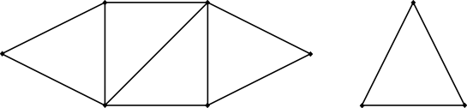

Figure 14
Recall that in a simple graph containing edge with end points and , . This is not the case with digraphs, the ordering of the vertices now becomes important. Thus if is an edge directed from to , we write 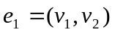, and note that 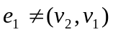. We call a directed edge.
Definition 23
In a digraph D, a directed edge is said to be incident from and incident to . Furthermore, we can say that is adjacent to , and that is adjacent from .
We must also revise the notion of the degree of a vertex to take into account the direction of edges in a digraph..
Definition 24
In a digraph D with a vertex v, the outdegree of v, denoted 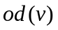, is the number of edges incident from v. The indegree of v, denoted 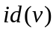, is the number of edges incident to v. D is said to be balanced if 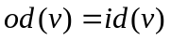.
Connectivity in digraphs is slightly different to connectivity in a simple graph, as the next definition explains.
Definition 25
A digraph D is said to strongly connected if for each vertex v, there is a directed path from v to any other vertex of D. We say that D is weakly connected if the underlying graph is connected. D is disconnected if it is not at least weakly connected.

Trees
Trees are a special type of graph. In this section we will discuss some of the fundamental properties of trees.
Definition 26
A tree is a connected graph which contains no circuits. Therefore trees are also known as acyclic graphs. A trivial tree is a graph that consists of a single vertex, and an empty tree is a tree that has no vertices or edges.

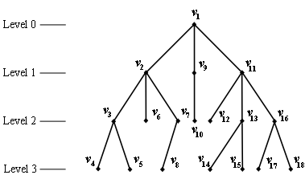

Figure 15
Figure 15 is an example of a tree.
Definition 27
A forest is a disconnected tree. This means that each component of the graph is a tree.

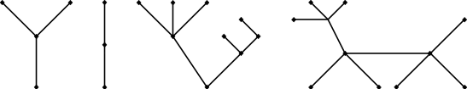

Figure 16
Figure 16 is an example of a forest with four components.
Definition 28
A rooted tree is a tree in which one vertex is distinguished from the others. This vertex is called the root.
In a rooted tree any vertex of degree one, unless it is the root, is called a leaf. In Figure 15 is the root of the tree, and the tree has 10 leaves. If a vertex is neither the root or a leaf, it is called an internal vertex.
Definition 29
The depth or level of a vertex in a rooted tree is the number of edges in the path from the root to that vertex. The height of a rooted tree is the maximum level of any vertex in the tree.
The rooted tree in Figure 15 has a height of 3, and the depth of each of the vertices is marked on the diagram.
Definition 30
Given any internal vertex v of a rooted tree, the children of v are all those vertices that are adjacent to v and one level further away from the root than v. If u is a child of v, then v is the parent of v. Vertices that are children of the same parent are called siblings.
In Figure 15 is a child of and a parent of and 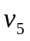. Vertices and are siblings.
Definition 31
Given vertices u and v in a rooted tree, if v lies on the path between u and the root, then v is an ancestor of u and u is a descendant of v.
The vertex in Figure 15 is an ancestor of and , but not of 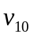.
Definition 32
A binary tree is a rooted tree in which every vertex, excluding leaves, has exactly two children.
See Figure 17 below for an example of a binary tree.
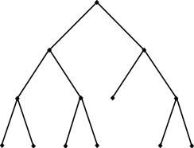

Figure 17
Definition 33
A spanning tree for a graph G is a subgraph of G that contains every vertex of G and is a tree.

Weighted Graphs
Under certain circumstances it is natural to associate a number with each edge in a graph. Simple examples include the lengths of roads on a map, or the time it takes to travel those roads.
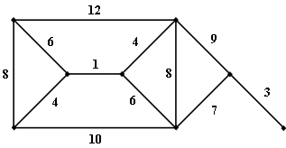

Figure 18
Definition 34
Given a graph G = (V, E) which has a number associated with each 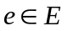, such a number is called a weight and is denoted by 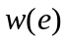. A graph with weighted edges is called a weighted graph.
Given a subgraph H of a graph G, we define its weight to be the sum of the weights of the edges of G.
Definition 35
A minimal spanning tree for a weighted graph W is a spanning tree of W that has the least possible total weight when compared to all other spanning trees for that graph.

